

OPEN EVERY DAY

PUBLIC WELCOME

j0257853

**CALL AHEAD – 852-GOLF(4653)**

**FREE LUNCHTIME DELIVERY WITH 6 ORDERS OR MORE**

**\*\*ORDERS MUST BE PLACED 1 HOUR PRIOR TO**

**PREFERRED DELIVERY TIME\*\***

THE

19TH

HOLE

RESTAURANT

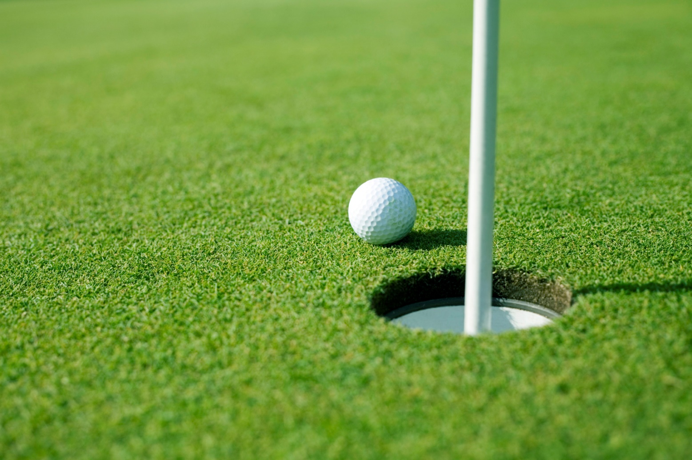

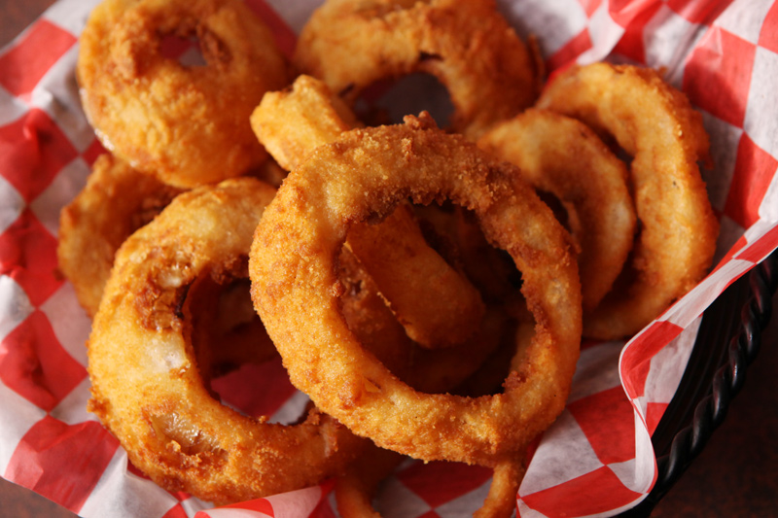

*APPETIZERS*

**Cheddar Cheese Cubes $5.00**

**Mozzarella Sticks $5.00**

**Cheddar Cauliflower $5.00**

**Breaded Mushrooms $5.00**

**Onion Rings $5.00**

**Combo Basket $8.00**

**(A sampling of all of the above)**

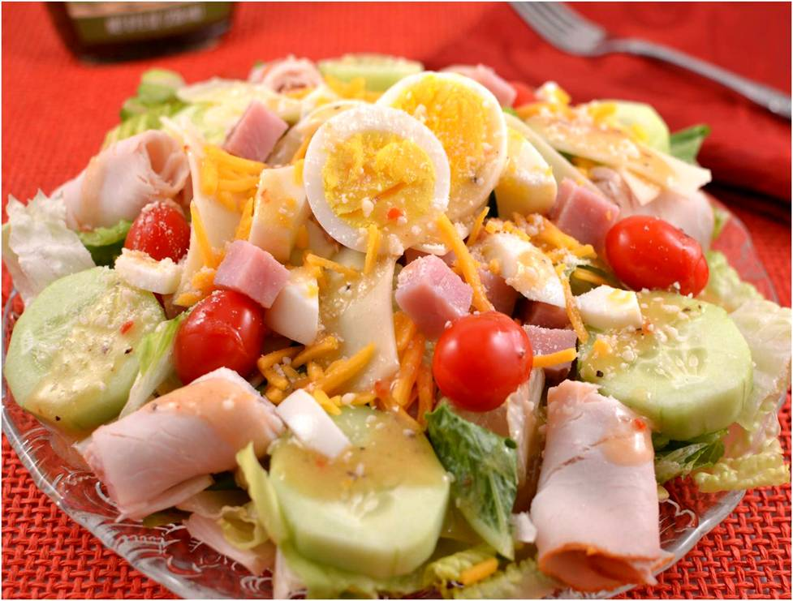

***SALADS***

**Chef Salad $6.00 Lg/$4.00 Sm**

***Garden fresh vegetables topped with***

***diced Turkey, Ham & Cheddar Cheese***

**Grilled Chicken Salad $6.00 Lg/$4.00 Sm**

***Garden fresh vegetables topped with***

***Grilled Chicken Breast & Cheddar Cheese***

**Dressings available: Ranch, French, Italian, Honey Mustard, Thousand Island, Poppy Seed, Fat Free Ranch & Raspberry Vinaigrette**

**Extra Dressing: $ .50 Blue Cheese: $.50**

***BEVERAGES***

**Fountain Pepsi, Diet Pepsi, Mountain Dew,**

**Root Beer, Iced Tea or Lemonade $1.50 Lg/$1.00 Sm**

**Coffee $1.25 Lg/$ .75 Sm**

**(*Free Refills of Fountain Pop and Coffee for Dine-In Only)***

**Milk $1.00 Hot Chocolate $1.00**

**12 oz. Draft (Bud Lite, Miller Lite, Coors Lite) $1.50**

**Six (6) Pack $10.00 Mixed Drinks $2.50**

**Domestic Beer (Can) $ 2.50 Pitcher $5.00**

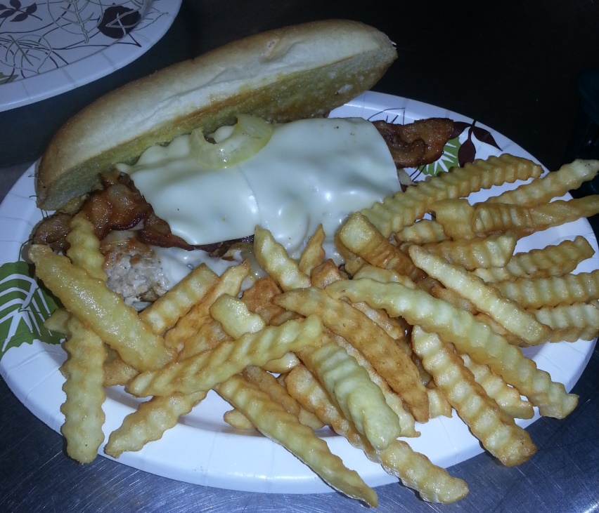

***TENDERLOINS***

***ALL SANDWICHES SERVED WITH CHIPS & PICKLE SPEAR***

**ULTIMATE TEE-NDERLOIN $7.50**

***Specially seasoned, grilled, unbreaded pork tenderloin topped with swiss cheese, bacon & grilled onions on a toasted hoagie roll***

**GRILLED TEE-NDERLOIN $6.50**

***Specially seasoned, grilled, unbreaded pork tenderloin on a toasted hoagie roll***

**BREADED TENDERLOIN $6.75**

***A classic breaded tenderloin overflowing a toasted Kaiser Roll.***

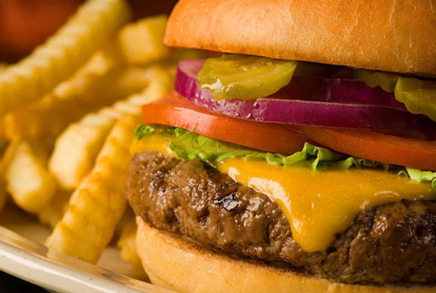

***CHICKEN***

***ALL SANDWICHES SERVED WITH CHIPS & PICKLE SPEAR***

**GRILLED CHICKEN BREAST $7.00**

***Grilled and seasoned to perfection served on a toasted Kaiser Roll***

**CRISPY CHICKEN BREAST-NEW! $7.00**

***A classic breaded chicken breast served on a toasted Kaiser Roll***

**CHICKEN STRIPS $6.00**

***Made with all white chicken served with your choice of sauce***

**CHICKEN WINGS (order of 6) $4.50**

***Sauces: BBQ, Marinara, Honey Mustard, Ranch,***

***Mild or Hot (Blue Cheese $ .50)***

***BURGERS***

***ALL SANDWICHES SERVED WITH CHIPS & PICKLE SPEAR***

**DOUBLE BACON CHEESEBURGER $9.50**

**BACON CHEESEBURGER $7.50**

**DOUBLE CHEESEBURGER $8.00**

**CHEESEBURGER $6.00**

**HAMBURGER $5.50**

**PATTY MELT $7.00**

***All burgers are ¼ lb ground beef patty, perfectly seasoned, char-broiled wine burgers served on a toasted Kaiser Roll.***

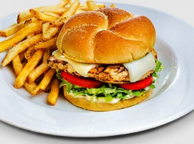

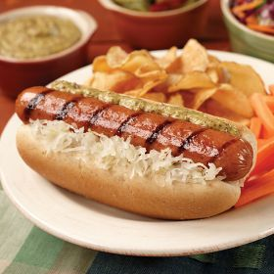

***SANDWICHES***

***ALL SANDWICHES SERVED WITH CHIPS & PICKLE SPEAR***

**B.L.T. $5.00**

**COD FISH FILET $5.50**

**GRILLED CHEESE $4.00**

**EGG SALAD $5.00**

**½ EGG SALAD $3.00**

**CHICKEN SALAD $5.00**

**½ CHICKEN SALAD $3.00**

**TUNA SALAD $5.00**

**½ TUNA SALAD $3.00**

**POLISH SAUSAGE $3.00**

**BRATWURST $3.00**

**HOT DOG $3.00**

**ADD CHEESE TO ANY ABOVE $0.50**

***SIDE DISHES***

**FRENCH FRIES $2.00**

**PASTA SALAD $2.00**

**POTATO SALAD $2.00**

**COTTAGE CHEESE $2.00**

**COLE SLAW $2.00**

**Served every day until 11am**

***BREAKFAST***

***EARLY BIRDIE SPECIAL***

**Includes 2 eggs, 4 slices of bacon, 2 sausage patties or 4 sausage links, hash browns & toast**

**$5.00**

***BABY BIRDIE SPECIAL***

**Includes 1 egg, 2 slices of bacon, 1 sausage patty or 2 sausage links, ½ order of hash browns & toast**

**$3.00**

***3 EGG OMELET $6.00 2 EGG OMELET $5.00***

***YOUR CHOICE OF THE FOLLOWING: Sausage, Ham, Bacon, Onion, Tomato, Mushroom,***

***Green Pepper, Black Olive, Jalapeno Pepper, Cheddar Cheese***

**EGG & CHEESE SANDWICH $3.00 PANCAKE $1.50**

**W/BACON OR SAUSAGE $3.50 CHOCOLATE CHIP PANCAKE $2.00**

**BISCUITS & GRAVY $5.00 1 SLICE FRENCH TOAST $2.00**

**½ ORDER $3.00 BAGEL W/CREAM CHEESE $1.50**

**ONE EGG $1.50 ENGLISH MUFFIN $1.00**

**TWO EGGS $3.00 TOAST & JELLY $1.00**

**BACON (4 STRIPS) $3.00 CUP OF SAUSAGE GRAVY $0.50**

**SAUSAGE (2 PATTIES OR 4 LINKS) $3.00 HASHBROWNS $2.00**

**HASHBROWNS W/CHEESE $2.50**