

OPEN EVERY DAY

PUBLIC WELCOME

j0257853

**CALL AHEAD – 852-GOLF (4653)**

**FOR RESERVATIONS OF 10 OR MORE**

**LUNCHTIME & DINNER DELIVERY WITH $20.00 PURCHASE**

**LUNCH DELIVERY 11AM-2PM/DINNER DELIVERY 4PM-7PM**

THE

19TH

HOLE

RESTAURANT



***BREAKFAST (AVAILABLE ALL DAY)***

***EARLY BIRDIE SPECIAL $6.50/BABY BIRDIE (1/2 PORTIONS) $4.50***

**Includes 2 eggs & choice of 4 slices of bacon, 2 slices of ham, 2 sausage patties, 4 sausage links,**

**or corn beef hash, hash browns & toast**

***3 EGG OMELET $6.50/2 EGG OMELET $5.50***

***YOUR CHOICE OF THE FOLLOWING: Sausage, Ham, Bacon, Onion, Tomato, Mushroom,***

***Green Pepper, Black Olive, Jalapeno Pepper, Cheddar Cheese***

**EGG & CHEESE SANDWICH $3.50 PANCAKE $1.75**

**W/BACON OR SAUSAGE $4.00 CHOCOLATE CHIP PANCAKE $2.00**

**BISCUITS & GRAVY $5.50 1 SLICE FRENCH TOAST $2.00**

**½ ORDER $3.50 BAGEL W/CREAM CHEESE $2.00**

**ONE EGG W/TOAST $2.00 ENGLISH MUFFIN $1.50**

**TWO EGGS W/TOAST $4.00 TOAST & JELLY $1.50**

**BACON (4 STRIPS) $3.00 CUP OF SAUSAGE GRAVY $0.50**

**SAUSAGE (2 PATTIES OR 4 LINKS) $3.00 HASHBROWNS $2.00**

**HAM (2 SLICES) $3.00 W/CHEESE $2.50**

**CORN BEEF HASH $3.00 FULLY LOADED $5.50**

**CINNAMON ROLL $2.50 ½ ORDER LOADED $3.00**

**AMERICAN FRIES $2.00 OATMEAL $2.50**

***BEVERAGES***

**Fountain Pepsi, Diet Pepsi, Mountain Dew, Root Beer, Iced Tea or Lemonade $1.50 Lg/$1.00 Sm**

**Coffee or Hot Tea $1.25 Lg/$ .75 Sm (*Free Refills of Fountain Pop and Coffee for Dine-In Only)***

**Milk $1.00 Hot Chocolate $1.00 Chocolate Milk $ 1.50**

**12 oz. Draft $ 2.00**

**Six (6) Pack $10.00 Shot $3.50**

**Domestic Beer $ 2.50 Top Shelf Drinks $3.50sm/$7.00lg**

**Pitcher $ 6.00 Glass of Wine $2.50**

**Mike’s Hard Lemonade $ 3.00 Palm Breeze $3.00**

***APPETIZERS***

**Cheddar Cheese Cubes $5.50 Cheddar Cauliflower $5.50**

**Breaded Mushrooms $5.50 Mozzarella Sticks $5.50**

**Onion Rings $5.50 Combo Basket $8.50**

**(A sampling of all the above)**

**SWEET TREATS DAILY**

***SWEET TREATS***

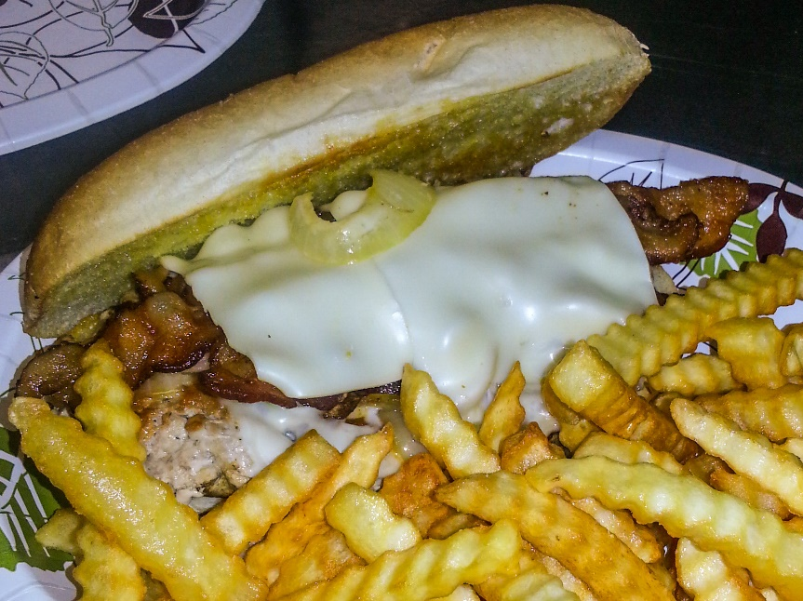

***TENDERLOINS***

***ALL SANDWICHES SERVED WITH CHIPS & PICKLE SPEAR***

***(ADD A SIDE - $1.00 ADDITIONAL)***

**ULTIMATE TEE-NDERLOIN $8.50**

***Specially seasoned, grilled, unbreaded pork tenderloin topped with swiss cheese, bacon & grilled onions on a toasted hoagie roll***

**GRILLED TEE-NDERLOIN $7.00**

***Specially seasoned, grilled, unbreaded pork tenderloin on a toasted hoagie roll***

**BREADED TENDERLOIN $7.00**

***A classic breaded tenderloin overflowing a toasted Kaiser Roll.***

***BURGERS***

***ALL SANDWICHES SERVED WITH CHIPS & PICKLE SPEAR***

***(ADD A SIDE - $1.00 ADDITIONAL)***

**DOUBLE BACON CHEESEBURGER $10.00**

**BACON CHEESEBURGER $ 7.50**

**DOUBLE CHEESEBURGER $ 8.00**

**DOUBLE HAMBURGER $ 7.00**

**CHEESEBURGER $ 6.00**

**HAMBURGER $ 5.50**

**PATTY MELT $ 7.00**

***All burgers are ¼ lb ground beef patty, perfectly seasoned, char-broiled wine burgers served on a toasted Kaiser Roll.***

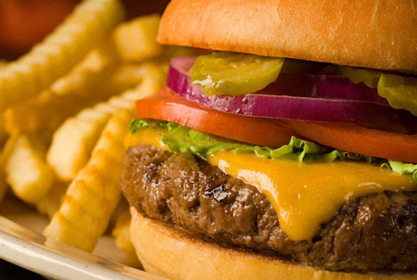

***SIDE DISHES***

**FRENCH FRIES $2.00**

**PASTA SALAD $2.00**

**POTATO SALAD $2.00**

**COTTAGE CHEESE $2.00**

**COLE SLAW $2.00**

**TUNA MAC $2.00**

**MAC & CHEESE $2.00**

**APPLESAUCE $2.00**

***SALADS***

**Chef Salad $7.00 Lg/$5.00 Sm**

***Garden fresh lettuce topped with***

***diced Turkey, Ham, Cheddar Cheese, Diced Tomato & Egg***

**Grilled Chicken Salad $7.00 Lg/$5.00 Sm**

***Garden fresh lettuce topped with***

***Grilled Chicken Breast, Cheddar Cheese & Diced Tomato (add Egg $ .50)***

**Crispy Chicken Salad $7.00 Lg/$5.00 Sm**

***Garden fresh lettuce topped with Crispy Chicken, Cheddar Cheese &***

***Diced Tomato (add Egg $ .50)***

**Dressings available: Ranch, French, Italian, Honey Mustard, Thousand Island, Poppy Seed, Fat Free Ranch, Blue Cheese & Raspberry Vinaigrette (Extra Dressing: $ .50)**

***CHICKEN***

***ALL SANDWICHES SERVED WITH CHIPS & PICKLE SPEAR***

***(ADD A SIDE - $1.00 ADDITIONAL)***

**GRILLED CHICKEN BREAST $7.00**

***Grilled and seasoned to perfection served on a toasted Kaiser Roll***

**CRISPY CHICKEN BREAST $7.00**

***A classic breaded chicken breast served on a toasted Kaiser Roll***

**CHICKEN STRIPS $6.50**

***Made with all white chicken served with your choice of sauce***

**CHICKEN WINGS (order of 6) $4.50**

***Sauces: BBQ, Marinara, Honey Mustard, Ranch,***

***Mild or Hot (Blue Cheese $ .50)***

***SANDWICHES***

***ALL SANDWICHES SERVED WITH CHIPS & PICKLE SPEAR***

***(ADD A SIDE - $1.00 ADDITIONAL)***

**B.L.T. $6.00**

**COD FISH FILET $6.00**

**GRILLED CHEESE $4.00**

**EGG, CHICKEN, TUNA SALAD $6.00**

**HOT OR COLD HAM OR TURKEY $6.00**

**BRATWURST $3.00**

**HOT DOG $3.00**

**ADD CHEESE TO ANY ABOVE $0.50**

**KID’S MENU**

**ALL MEALS INCLUDE 8OZ DRINK**

**5 MINI CORNDOGS W/2 SIDES $5.50**

**2 CHICKEN STRIPS W/2 SIDES $5.50**

**KID’S HAMBURGER W/2 SIDES $5.00**

**KID’S CHEESEBURGER W/2 SIDES $5.50**

**GRILLED CHEESE 2/2 SIDES $5.50**

**HOT DOG W/2 SIDES $5.50**

***SIDES: APPLESAUCE, GO-GURT, FRIES,***

***MAC & CHEESE***