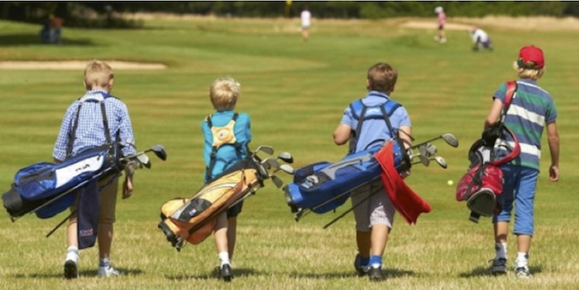

**KEWANEE PARK DISTRICT YOUTH GOLF PROGRAM**

**Free Golf School**

Monday, Tuesday and Thursday; JUNE 7–17 AND JULY 5-15

Ages 13 & over 8:00am – 9:00am

Ages 9 – 12 9:30am – 10:30am

Ages 8 & under 11:00am – 12:00pm

**Junior Golf League**

Play will be Wednesday mornings June 9th through July 21st

***Ages 13 & over 8:30am 9 holes***

Non-season ticket holders $5.00/week includes greens fees

$5.00/week Hot dog, chips & drink after play

Season ticket holders $5.00/week includes greens fees, hot dog, chips & drink

***Ages 9-12 9:30am 5 holes***

$5.00/week includes greens fees, hot dog, chips & drink after play

***Ages 8 & under 10:30am 4 holes***

$5.00/week includes greens fees, hot dog, chips & drink after play

**\*\*\*NOTE***ALL CHILDREN UNDER 7 MUST HAVE SUPERVISION ON THE COURSE.**

**ONLY 1 ADULT & 2 CHILD ALLOWED IN GOLF CARTS**

---------------------------------------------------------------------------------------------------------

Registration form for GOLF SCHOOL and/or GOLF LEAGUE

Name: ____________________________________________ Age: _____________

Address: ____________________________Golf School? ________ League?________

Phone: _________________________ Season Ticket Holder: ____YES _____NO

**REGISTRATION DEADLINE: MAY 21, 2021**

Registrations can be mailed to the Kewanee Park District, PO Box 424, Kewanee, IL 61443 or dropped off at 1095 Cambridge Road, Kewanee, IL 61443

For more information contact the Kewanee Park District (309)852-2872

TIME TO HOOP IT UP!